**Testing a model to track marine fish migrations in polar regions using satellite tags**

*Bjørn Ådlandsvik1, Cedar M. Chittenden2, Ole-Petter Pedersen2, David Righton3 and Audun H. Rikardsen2

# *1Institute of Marine Research, P.O. Box 1870, Nordnes, N-5817 Bergen, Norway*

*2Department of Arctic and Marine Biology, University of Tromsø, N-9037 Tromsø, Norway*

*3Center for Environment, Fisheries and Aquaculture Science, Pakefield Road, NR33 0HT Lowestoft, UK*

\**Correspondence*. e-mail: bjorn.adlandsvik@imr.no

**Abstract**

The use of satellite tags to geo-locate marine fishes in polar regions is challenging due to the brevity of periods during which there is a defined sunrise and sunset. Models using other environmental parameters, such as temperature and depth, are thus required to supplement geo-location data in the estimation of marine migratory routes. A forward/backward-Lagrangian model using biased random walks was adapted to satellite tag data from migrating Atlantic salmon (*Salmo salar*), and known geo-locations were used to test and constrict the model. The model accurately predicted migratory routes that fit the light-based geo-locations calculated by the tags. Sensitivity analyses demonstrated that slight alterations of the start and end points did not significantly affect the mean migratory route estimates. This model can be applied to archival tag data from any surface- or bottom-dwelling marine species as an alternative to light-based geo-location methods.

**Key words**: Atlantic salmon, forward/backward-Langrangian, PSAT, Arctic, fish, SST, temperature, depth, telemetry, archival tag

**Introduction**

Satellite telemetry has been used for decades to track marine migratory species, including reptiles (e.g. Luschi *et al*., 1996; Hughes *et al*., 1998), birds (e.g. Jouventin and Weimerskirch, 1990; Georges *et al*., 1997), and mammals (e.g. Lowry *et al.*, 1998; Richards *et al*., 1998). As satellite tags do not require an animal to be recaptured in order for data to be obtained, they are particularly useful for species with long migrations in the open ocean (Mate *et al*., 1998; Gillespie, 2001). However, for data to be uploaded to a satellite, the tag’s antenna must be pointing upward and in air—making the study of most fish species all but impossible. Pop-up satellite archival tags, or PSATs, are a recently developed technology for the study of aquatic species (Aarestrup *et al*., 2009). PSATs are buoyant and can be programmed to release from a tagged animal on a certain date, or when an animal has remained at a constant depth for a pre-determined period of time (in the case of a probable mortality). Once at the surface, the tag transmits the stored environmental data to passing satellites. PSATs have been tested on several large marine fish species (e.g. Lutcavage *et al.*, 1999; Arrizabalaga *et al.*, 2008) and have recently been made compact enough to be used on smaller fish (Aarestrup *et al.*, 2009).

PSAT tags generally record the temperature, depth and light intensity at regular time intervals, although other types of environmental sensors can be attached (e.g. salinity, chlorophyll recorders; Teo *et al.,* 2009). Algorithms programmed into the tags calculate geo-locations using estimates of sunrise and sunset derived from collected light-level data. For locations at which sunset and sunrise are defined by rapid and large changes in visible light-level, light-based geo-location is effective. However, at polar latitudes, where light levels are often low, and the difference in light-level between night and dawn/ dusk is minimal, accurate geo-location estimates are possible only during brief periods before and after the spring and autumn equinoxes (Fig. 1). Even during these periods of possible geo-location, the difference in irradiance between day and night is much less than in tropical regions, which adds error to the estimates. Furthermore, the duration of twilight is greater at higher than at lower latitudes, making the estimation of exact sunrise and sunset time challenging, especially with the additional confounding factors acting to lower light levels (e.g. diving behaviours or adverse weather conditions). In consequence, most PSAT-based studies of migratory behaviour of marine animals have been focused on species that spend time at lower latitudes, such as bluefin tuna (Block *et al*., 2005) or leatherback turtles (Hays *et al*., 2006).

Information on the migration and distribution of fishes at high latitudes is highly important, however, as these areas support some of the most lucrative fisheries in the world, many of which are becoming severely depleted (Sakshaug *et al.* 2009). For example, anadromous Atlantic salmon (*Salmo salar*) and Pacific salmon species (*Oncorhynchus* spp.) undertake long feeding migrations into northern oceans where observational studies are challenging (Hansen and Quinn, 1998; Rikardsen *et al*., 2008). Salmonids are surface-oriented, using the top 10 m of the water column for primary habitat during their saltwater phase (Rikardsen and Dempson, 2010). The open-ocean migratory behaviour of salmonids has been pieced together over the last century from fishing catch data and mark-recapture studies (Hansen and Jacobsen, 2000; Rikardsen *et al.*, 2008). In short, there exists almost no data beyond commonly fished areas and data density is low and, without any continuous real-time data, great knowledge gaps exist in terms of the actual marine distribution of salmon, salmonid migratory routes, and environmental effects on salmonid marine behaviour (Chittenden *et al.*, 2009). Satellite tags are perhaps the only technology currently available that could enable researchers to overcome this problem and fill the existing gaps. Although, with the problems associated with light-based geo-location at polar latitudes, additional methods to determine location are required.

A number of different approaches have been applied to the problem of predicting the state-space of migrating organisms. In general, they differ with respect to the applied theoretical frameworks, forcing fields, and data assimilation methods (i.e. to which extent the model is able to incorporate and use external data as correctors). In the simplest cases, models have been developed that can reconstruct the horizontal movements of migrating fish by matching hydrographical fields to data collected by tagged fish (Metcalfe and Arnold, 1997; Righton and Mills, 2006; Ådlansvik *et al*., 2007; Tremblay *et al.*, 2009). More complex models use various statistical techniques, including Bayesian models (Kurota *et al*., 2009), bootstrapping techniques (Tremblay *et al.*, 2009), and weighted kernel estimation techniques (Walli *et al*., 2009) to provide likelihood-based estimates of geo-location. The variety of modeled and measured physical fields that have been applied to force and correct the migratory trajectories that result grows year on year (Booker *et al*., 2008).

Our model approach was to use a forward/backward-Lagrangian model with a biased random walk (Patterson *et al.*, 2007; Ådlandsvik *et al.*, 2007). The objectives of our work were fourfold:

1. To adapt the method of Ådlandsvik *et al*. (2007) to salmon behaviour data;
2. To test the accuracy of the model with PSAT geo-location data;
3. To run a sensitivity analysis on the model, altering the release and pop-up locations; and
4. To use the geo-locations as stop/start points to constrain the model and improve the precision of the tracks.

**materials and Methods**

*Model description*

The model creates a set of trajectories consistent with the available information from the tag. Two sets of trajectories are generated—one progressing forward from the release site, and one progressing backward from the pop-up position. The trajectories progress by combining a deterministic and a stochastic velocity component. The deterministic component pulls the particle at a velocity that would get the particle to the final position in the time available. The stochastic component is a random walk velocity, with a fixed speed and an arbitrary/random direction.

*** Need to be more explicit about this...is the deterministic component a fixed velocity, fixed angle trajectory between release and recapture? Is the random walk element applied each day? If so, how are the distributions that the step-length and turn-angles are drawn from defined?

After each time step (one day), the environmental (depth and temperature) dataset was sampled at the position of the trajectory. If the tag data were not consistent with the environmental data at the new position, the trajectory was given a second chance by returning it to the previous position and doing what? If the previous position also failed, the trajectory was terminated. As a final step, the forward and backward trajectories were merged at the temporal midpoint between the release and pop-up sites. This was done by looping through the active forward trajectories and choosing the nearest backwards trajectory if the midpoint positions were closer than a given threshold. The model is described further and in more detail in Ådlandsvik *et al.* (2007).

*Model set up*

Two environmental data sets were used—bathymetry and sea surface temperature (SST). For bathymetry, we have used the gridded ETOPO1 dataset provided online by the NOAA National Geophysical Data Center from their Web site at <http://www.ngdc.noaa.gov/mggd/> (Amante and Eakins, 2009). This data set has a resolution of one minute. For SST, we used the gridded dataset NOAA_OI_SST_V2 provided online by the NOAA Earth System Laboratory from their Web site at <http://www.esrl.noaa.gov/psd/> (Reynolds *et al.,* 2002). This dataset has one degree spatial and one week temporal resolution. The datasets are sampled at the track positions by multi-linear interpolation.

The tag data were prepared by computing hourly averages of SST and hourly maximum depth. Missing data (mostly due to lack of surface temperature within the hour) were filled by linear interpolation. Rapid changes in temperature recorded by the tag were smoothed by a .... day moving average, to fit the lower resolution of the SST archive. Sub-grid variation was also accounted for by thresholds for termination. These thresholds were narrow, so that the termination criteria were effective and provided a good selection pressure for the trajectories. However, they were flexible enough to give a reasonable subset of active trajectories.

Depth was used as a one-sided limiter terminating trajectories where the sampled depth (Hetopo) was shallower than the tag’s recorded depth. The limiter had the following algebraic formulation:

Htag < a*Hetopo + H0

For temperature, a symmetric two-sided criterion was used. Each trajectory had to satisfy the criterion:

| TSST - Ttag | < dT

The values used are given in the table below.

[Here comes a table with different settings]

T: average temperature at 0 m by day

D: maximum daily depth (* 1.3 + 30)

*The salmon data*

Two PSAT datasets from female salmon kelts were used to test the model. A ‘kelt’ is a post-spawned adult salmon that leaves its freshwater spawning grounds to return to ocean feeding areas. The fish were caught by anglers during late May in the Alta River (70°N 23°E), northern Norway (Fig. 2). A PSAT tag recording temperature, depth and geo-location (Microwave Telemetry, Inc.) was attached externally to each fish by bridling the tag to two cushioned backplates that were wired through the dorsal musculature below the dorsal fin. An acoustic tag was also attached to one of the backplates so that the fish could be tracked as they moved out of the fjord after release. Following surgery, the tagged salmon were transported to the release site (Fig. 2) by boat. The fish in this study were in excess of 1m in length (tag 1: 111 cm long, 9.9 kg; tag 2: 101 cm long, 7.6 kg). They were released on the 22 May 2008 and took approximately three days to leave the release fjord.

The tags released from their attachments after 181 days (>472 km) and 146 days (>579 km). The tags were released earlier than their programmed pop-off date, presumably because the ‘constant depth’ failsafe was triggered after each tag had spent four consecutive days at the sea surface. It is probable that the tags and harnesses had detached from the fish (possibly predation) by this point. Thus, the tags were likely drifting with surface currents for four days prior to the initialisation of uploading their location to the ARGOS satellites, requiring back-calculation of initial release. Real-time ARGOS geo-location data from the four days following the initiation of the data upload were used to determine the daily change in latitude and longitude experienced by the tags due to surface current. These latitudinal and longitudinal differences were then subtracted from the geo-location at the start of the upload.

*Validation of PSAT geo-locations*

Unlike PSAT data obtained at lower latitudes, the longitude estimates from tags deployed in polar regions are unreliable during most of the year. This precludes the use of established validation methods, where longitude is ‘fixed’ and matched with SST data at a range of latitudes (e.g. Teo *et al.*, 2004). Another method was developed here to validate the geo-locations from polar latitudes.

A first filtering deleted those outliers that were on land and those due to false sunset/sunrise calculations (e.g. due to deep diving behaviour). A second filtering removed those data points that had temperatures 0.5°C above or below the actual sea-surface temperature (SST) at that location. Two temperature parameters were calculated from the tag data: 1) the mean daily temperature recorded at <10 m and 2) the mean daily temperature at <5 m. SST data within 0.5° latitude and longitude of each geo-location provided by the tags were extracted from the daily SST product provided by OSTIA (http://ghrsstpp.metoffice.com/pages/latest_analysis/ostia.html). If the temperature parameters were within 0.5°C of the SST ±0.5° latitude/longitude, the geo-location was deemed valid.

**Results**

*Validated geo-locations*

Accurate geo-locations were possible to obtain during two periods of the study; late August/early September and October. Near the autumnal equinox (22 September) daylength is the same at all latitudes, and during summer/winter there are 24 hours of daylight/darkness, both of which make geo-locating using sunlight impossible. Furthermore, the transition between daylight and darkness at sunrise/sunset is longer at polar latitudes, which add error to geo-location data. Tag 1 had a greater number of rejected geo-location estimates, and fewer validated geo-location estimates than tag 2 (Figure 3).

*Testing the model*

Most of the trajectories were terminated after they passed through an inconsistent position at some point along their track. For the first 60 days the mean track headed northwards (Figure 4). Following that, the path turned southwards for 40 days before heading northwards again. At the 400 m isobaths it veered northeast along the southern flank of the Bear Island Trench.

*** This needs to be more generic and related to the success of the modelling approach, as opposed to a description of a reconstruction.

When the modelled tracks were compared with the tag data (Figure 5), we found that the unterminated tracks showed a rapid northward movement during the first 60 days. This could be explained by the deep dives that the kelts undertook at the end of July, which would only be possible above 73°N. Towards the end of August and during the first half of September, the kelts dives became shallower and the temperature increased, indicative of more southerly latitudes. This pulled the unterminated tracks southward again. From the end of September onward, the kelts began diving more deeply again, which forced the unterminated tracks northward to the Bear Island Trench. The colder temperature recordings and the short period before the pop-up date then forced the tracks towards the northeast.

Validated geo-locations were used to check the fit of the model at eight points in time (Fig. 6). In six out of eight cases, the geo-locations were in the center of gravity of all the particle locations.

*Sensitivity analysis*

Minor modifications of release and pop-up locations did not change the overall pattern formed by the data from the tag and the environment (Fig. 7). The mean was robust and did not depend critically on either the release or pop-up locations (error range?)

*Constraining the model*

(Figure 8. Best estimate plot funnelled through geo-locations)

**Discussion**

In areas that are difficult to track migrating animals using light-based geo-location, other methods may be required. Our forward/backward-Lagrangian model using biased random walks was successful at reconstructing the migratory routes of Atlantic salmon using only temperature and depth recordings from a PSAT tag. Sensitivity analyses found that slight alterations of the start and end points did not change the mean trajectory route, suggesting that the model was robust and that the reconstructed tracks reflect the genuine migration of the salmon kelts, rather than model artefacts.

Bugs in the model, challenges of adapting the model to salmon, comparison with other models used to rebuild migratory routes, etc.

Analysis of reasons for major terminations of trajectories… OPP you were looking at this… should we include a table? Any thoughts on this?

Concerns about the accuracy of the tag algorithms for geo-location. Even during the prime geo-location times, the tags calculate widely variable geo-locations, perhaps due to deep dives, changes in weather, or a lack of sensitivity in the tag algorithm at detecting exact sunrise/sunset times. Thus, validated geo-locations may still contain some error.

Moving forward, further applications…

It would be possible to develop the model into a genetic algorithm by spawning new generations of trajectories as perturbations of the successful ones in the previous generation. This has not yet been implemented.

Possible references to include:

(Metcalfe and Arnold 1997) using depth and temperature to track plaice with confirmation by geo-location.

(Tremblay *et al.*, 2009) bootstrapping random walks biased by forward particles, uses recorded data accuracy estimates, assimilates other sources of data like SST, depth, boundaries. Tested using ARGOS and geoloc tracks from seals.

(Tremblay *et al.*, 2006) interpolation of geo-location using 6 algorithms. Bezier, hermite and cubic splines, linear algorithm. Interpolated tracks compared to intact tracks. Tracks were more accurate using curvilinear interpolation.

(Christensen *et al.*, 2007) hydrodynamical and individual-based model to look at larval backtracking

(Kurota *et al.*, 2009) spatially structured Bayesian model applied to PSAT, DST, conventional tags to look at mortality rates and movement.

(Booker *et al.*, 2008) model to simulate migration of Atlantic salmon using random swimming direction, rehotaxis and thermotaxis as time steps.

(Walter *et al.*, 1997) spatially explicit individual-based modelling using surface currents and behavioural rules for Pacific salmon.

(Patterson *et al.*, 2007) Review of state-space models of individual animal movement.

(Jonsen *et al.*, 2003) meta-analysis of animal movement using state-space models

(Jonsen *et al.*, 2005) state-space model of three seal pathway sets

(Walli *et al.*, 2009) weighted kernel estimation technique to remove bias of deployment location and track length

Pedersen et al (2008) hidden Markov model for geo-location using depth and temperature time-series.

**conclusion**

This forward/backward-Lagrangian model has the potential to rebuild the migratory routes of marine species using only temperature and/or depth recordings from archival tags. It could also be adapted to use other parameters such as salinity, chlorophyll, or magnetic-field recordings.

**Acknowledgements**

We thank Kathrine Michalsen, Jenny Jensen, Ceselie Lien, Amund Suhr, the Norwegian Research Council, and the Alta Laksfiskeri Interessentskap.

**References**

Aarestrup, K., Økland, F., Hansen, M.M., Righton, D., Gargan, P., Castonguay, M., Bernatchez, L., Howey, P., Sparholt, H., Pedersen, M.I. and McKinley, R.S. (2009) Oceanic Spawning Migration of the European Eel (*Anguilla anguilla*). *Science* **325**:1660.

Amante, C. and Eakins, B.W. (2009) ETOPO1 1 Arc-Minute Global Relief Model: Procedures, Data Sources and Analysis. NOAA Technical Memorandum NESDIS NGDC-24, 19 pp, March 2009.

Arrizabalaga, H., Pereira, J.G., Royer, F., Galuardi, B., Goni, N., Artetxe, I., Arregi, I. and Lutcavage, M. (2008) Bigeye tuna (*Thunnus obesus*) vertical movements in the Azores Islands determined with pop-up satellite archival tags. *Fish. Oceanog.* **17**:74–83.

Batchelder, H.P. (2006) Forward-in-time-/backward-in-time trajectory (FITT/BITT) modeling of particles and organisms in the coastal ocean. *Am. Meteor. Soc.* **23**:727-741.

Block, B.A., Teo, S., Walli, A., Boustany, A., Farwell, C., Dewar, H., Weng, K. and Williams, T. (2005) Electronic tagging and population structure of Atlantic bluefin tuna. *Nature* **434**:1121-1127.

Booker, D.J., Wells, N.C. and Smith, P.I. (2008) Modelling the trajectories of migrating Atlantic salmon (*Salmo salar*). *Can. J. Fish. Aquat. Sci.* **65**:352-361.

Chittenden, C., Beamish, R.J and McKinley, R.S. (2009) A critical review of Pacific salmon marine research relating to climate. *ICES J. Mar. Res.* **66**:2195-2204.

Georges, J., Guinet, C., Jouventin, P. and Weimerskirch, H. (1997) Satellite tracking of seabirds: interpretation of activity pattern from the frequency of satellite locations. *IBIS.* **139**:403–405.

Gifford, A., Compagno, L.J.V., Levine, M. and Antoniou, A. (2007) Satellite tracking of whale sharks using tethered tags. *Fish. Res.* **84**:17–24.

Gillespie, T.W. (2001) Remote sensing of animals. *Progr. Phys. Geog.* **25**:355-362.

Hansen, L.P. and Jacobsen, J.A. (2000) Distribution and migration of Atlantic salmon *Salmo salar* L., in the sea. In: *The Ocean Life of Atlantic Salmon – Environmental and Biological Factors Influencing Survival.* D. Mills (ed). Oxford: Fishing News Books, pp. 75–87.

Hansen, L.P. and Quinn, T.P. (1998) The marine phase of the Atlantic salmon (*Salmo salar*) life cycle, with comparisons to Pacific salmon. *Can. J. Fish. Aquat. Sci.* **55**(S1):104-118.

Hays, G.C., Hobson, V.J., Metcalfe, J.D., Righton, D. and Sims, D.W. (2006) Flexible foraging movements of leatherback turtles across the North Atlantic Ocean. *Ecology* **87**:2647-2656.

Hughes, G.R., Luschi, P., Mencacci, R. and Papi, F. (1998) The 7000-km oceanic journey of a leatherback turtle tracked by satellite. *J. Exp. Mar. Biol. Ecol.* **229:**209–17.

Jerlov, N.G. and Nielsen, E.S., Eds. (1974) *Optical aspects of oceanography*. Academic Press, London, New York. 494 pp.

Jouventin P. and Weimerskirch, H. (1990) Satellite tracking of wandering albatrosses. *Nature* **343**:746–748.

Kurota, H., McAllister, M.K., Lawson, G.L., Nogueira, J.I., Teo, S.L.H. and Block, B. (2009) A sequential Bayesian methodology to estimate movement and exploitation rates using electronic and conventional tag data: application to Atlantic bluefin tuna (*Thunnus thynnus*). *Can. J. Fish. Aquat. Sci.* **66**:321-342.

Lowry, L.L., Frost, K.J., Davis, R., DeMaster, D.P. and Suydam, R.S. (1998) Movements and behavior of satellite-tagged spotted seals (*Phoca largha*) in the Bering and Chukchi Seas. *Polar Biol.* **19**:221-230.

Luschi, P., Papi, F., Liew, H.C. and Chan, E.H. (1996) Long-distance migration and homing after displacement in the green turtle (*Chelonia mydas*): a satellite tracking study. *J. Comp. Physiol.* **178**:447–52.

Lutcavage, M.E., Brill, R.W., Skomal, G.B., Chase, B.C. and Howey, P.W. (1999) Results of pop-up satellite tagging of spawning size class fish in the Gulf of Maine: do North Atlantic bluefin tuna spawn in the mid-Atlantic? *Can. J. Fish. Aquat. Sci.* **56**:173–177.

Mate, B.R., Gisiner, R. and Mobley, J. (1998) Local and migratory movements of Hawaiian humpback whales tracked by satellite telemetry. *Can. J. Zool.* **76:**863–68.

Metcalfe, J.D. and Arnold, G.P. (1997) Tracking fish with electronic tags. *Nature* **387**:665–666.

Patterson, T.A., Thomas, L., Wilcox, C., Ovaskainen, O. and Matthiopoulos, J. (2007) State-space models of individual animal movement. *Trends Ecol. Evol.* **23**:87-94.

Pedersen, O.P., Tande, K.S. and Slagstad, D. (2000) A synoptic sampling method applied to *Calanus finmarchicus* population on the Norwegian mid-shelf in 1997. *Mar. Ecol. Prog. Ser.* **204**:143-157.

Pedersen O.P., Aschan, M., Rasmussen, T., Tande, K.S. and Slagstad, D. (2003) Larval dispersal and mother populations of *Pandalus borealis* investigated by a Langrangian particle-tracking model. *Fish. Res.* **65**:173-190.

Reynolds, R.W., Rayner, N.A., Smith, T.M., Stokes, D.C. and Wang, W. (2002) An improved in situ and satellite SST analysis for climate. *J. Climate* **15**:1609-1625.

Richards, P.R., Heide-Jorgensen, M.P. and Aubin, D.S. (1998) Fall movements of Belugas (*Delphinapterus leucas*) with satellite-linked transmitters in Lancaster Sound, and northern Baffin Bay. *Arctic* **51**:5–16.

Righton, D. and Mills, C.M. (2008) Reconstructing the movements of free-ranging demersalfish in the North Sea: a data matching and simulation method. *Mar. Biol.***153**:507-521.

Rikardsen, A.H. and Dempson, B. (2010) Dietary life-support: The marine feeding of Atlantic salmon (Chapter 5). In: *Salmon Ecology* (Aas, Ø., Einum, S., Klemetsen, A., Skurldal, J. eds). Wiley Blackwell.

Rikardsen, A.H., Hansen, L.P., Jensen, A.J., Vollen, T. and Finstad, B. (2008) Do Norwegian Atlantic salmon feed in the northern Barents Sea? Tag recoveries from 70 to 78°N. *J. Fish Biol.* **72**:1792-1798.

Sakshaug, E., Johnsen, G. and Kovacs, K. (Eds.) (2009) *Ecosystem Barents Sea.* Tapir Academic Press, Trondheim, Norway.

Teo, S.L., Kudela, R., Rais, A., Perle, C., Costa, D.A. and Block, B. A. (2009) Estimating chlorophyll profiles from electronic tags deployed on pelagic animals. *Aquat. Biol.* **5**:195-207.

Teo, S.L.H., Boustany, A., Blackwell, S., Walli, A., Weng, K.C. and Block, B.A. (2004) Validation of geo-location estimates based on light level and sea surface temperature from electronic tags. *Mar. Ecol. Prog. Ser.* **283**: 81-98.

Tremblay, Y., Robinson, P.W. and Costa, D.P. (2009) A parsimonious approach to modelling animal movement data. *PLoS ONE* **4**:e4711.

Walli, A., Teo, S.L.T., Boustany, A., Farwell, C.J., Williams, T., Dewar, H., Prince, E. and Block, B. (2009) Seasonal movements, aggregations and diving behaviour of Atlantic bluefin tuna (*Thunnus thynnus*) revealed with archival tags. *PLoS ONE* **4**:e6151.

Ådlandsvik, B., Huse, G. and Michalsen, K. (2007) Introducing a method for extracting horizontal migration patterns from data storage tags. *Hydrobiologia* **582**:187-197.

**FIGURES**

Figure 1. The theoretical light intensity at sea surface as a function of latitude and time (calculated according to Jerlov and Nielsen, 1974). Whereas geo-location is possible at all times of the year near from the equator to the polar circles, at polar latitudes (75°N), geo-location zones are limited (shaded area).

Figure 2. The study area, including release site and model run start locations A, A2, A3, B, C and D.

Figure 3. Map of the geo-locations estimated by a) tag 1, and b) tag 2. Colours denote the reason for the validation or rejection of each geo-location.

Figure 4. A random selection of 200 possible trajectories from a total of 21,556 merged tracks from the standard run for a) tag 1, and b) tag 2. The red curve gives the average of all tracks, and the white disks indicate 10-day intervals.

Figure 5. Temperature and depth for a) tag 1, and b) tag 2.

Figure 6. Snapshot plots of particle locations and center of gravity (blue ovals) at the time of each geo-location for a) tag 1, and b) tag 2.

Figure 7. Sensitivity analysis plots of the mean pathways for tag 1, with various start and pop-up locations.

Figure 8. A best-estimate plot funnelled through the validated geo-locations for tag 1.

Figure 1

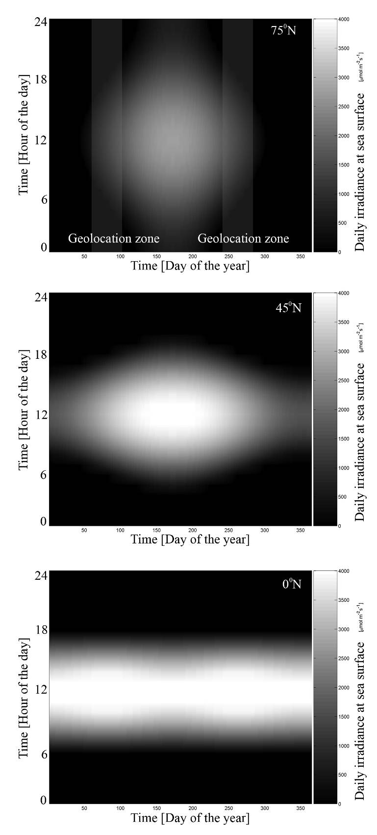

Figure 2

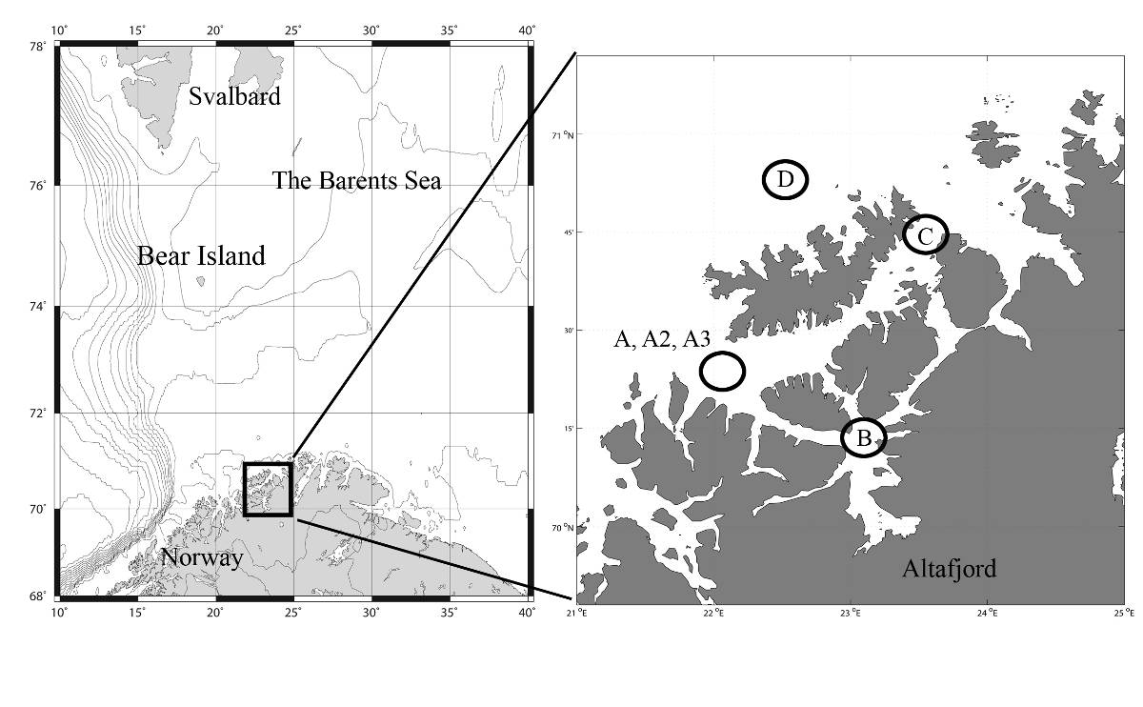

Figure 3a

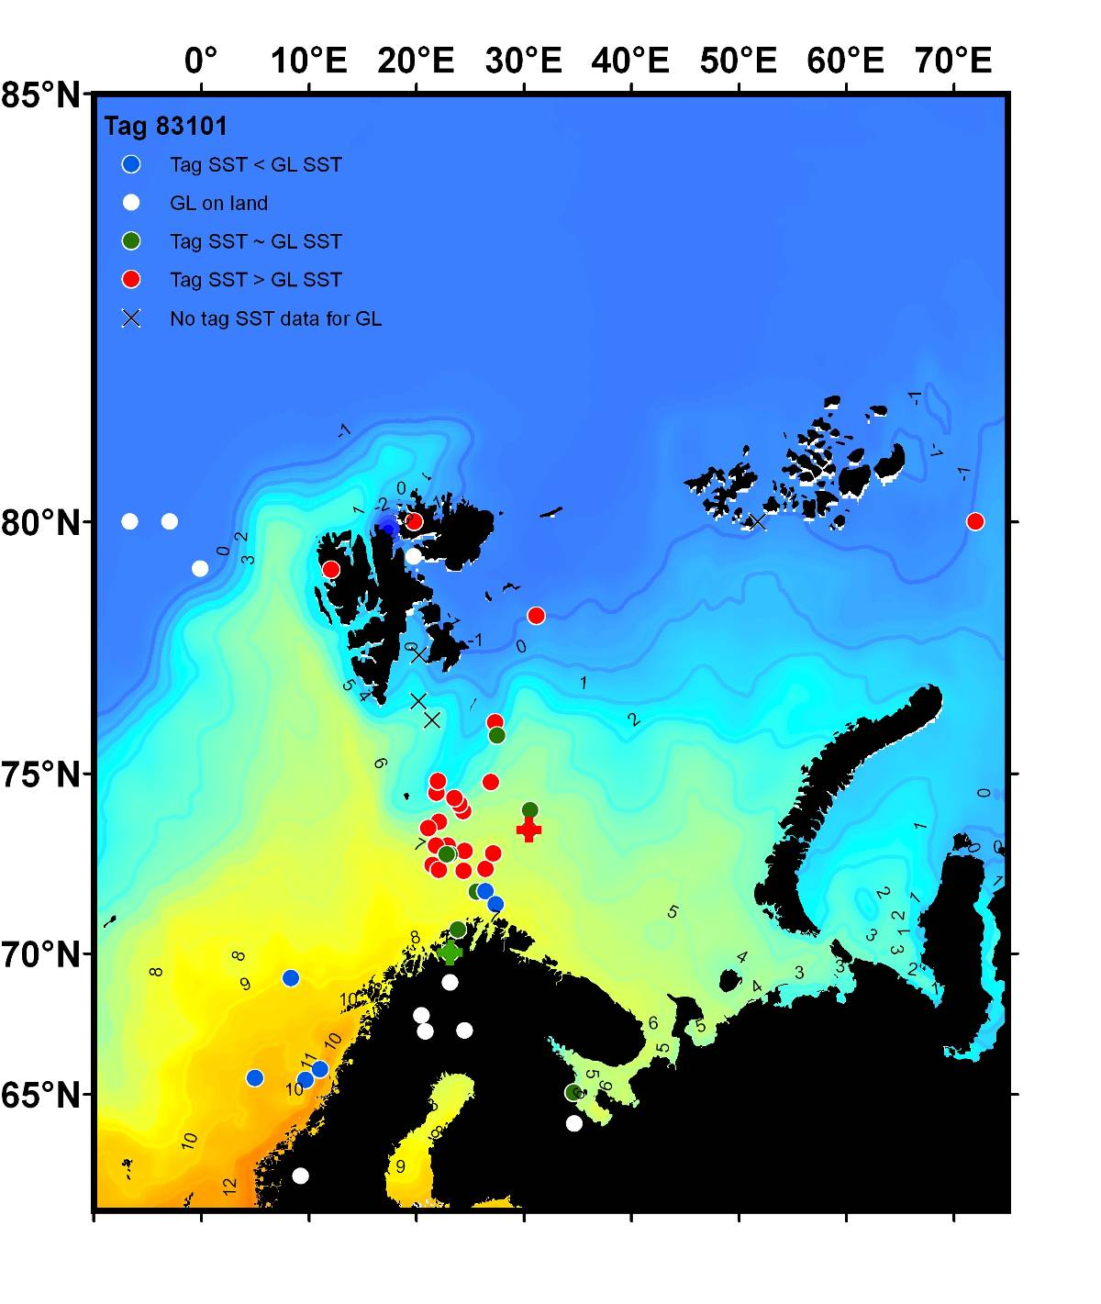

Figure 3b

Figure 4a

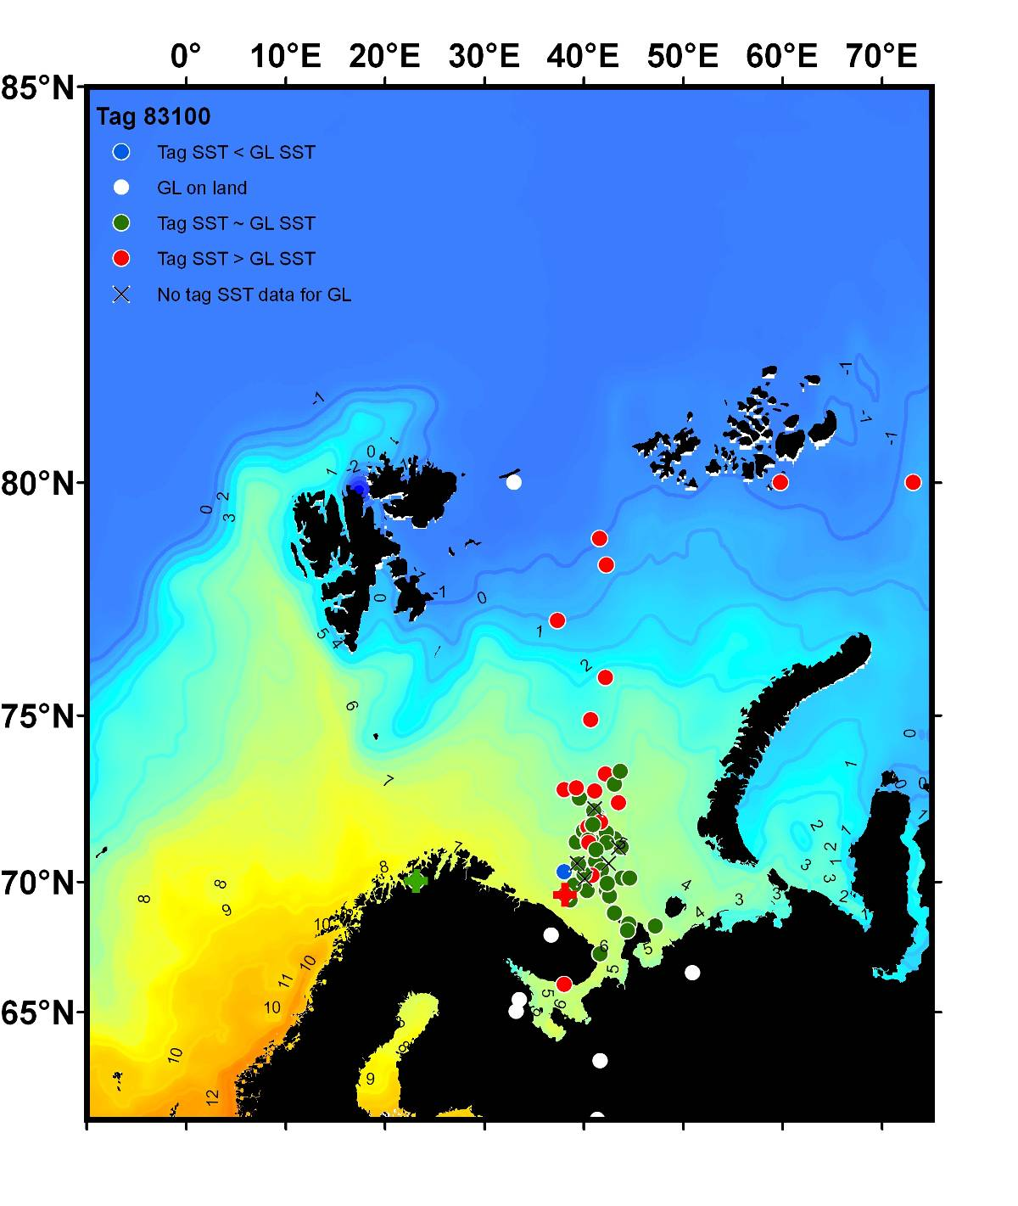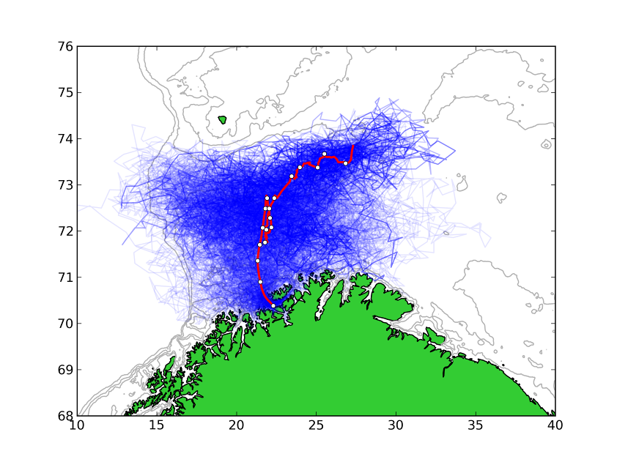

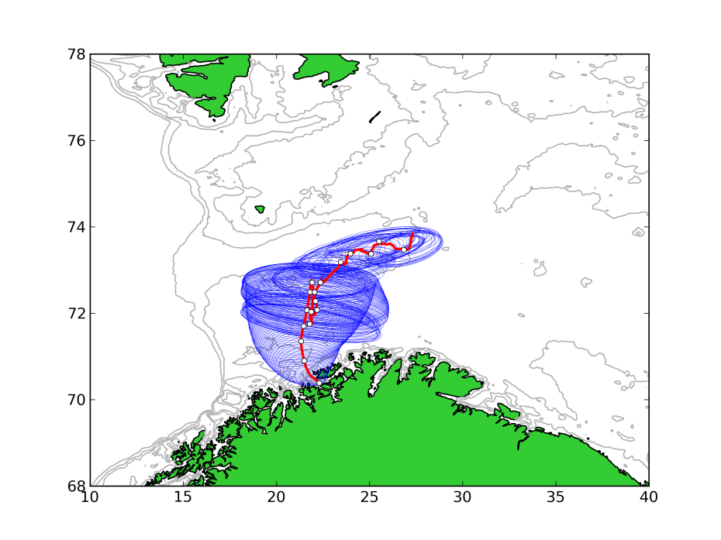

Figure 4b

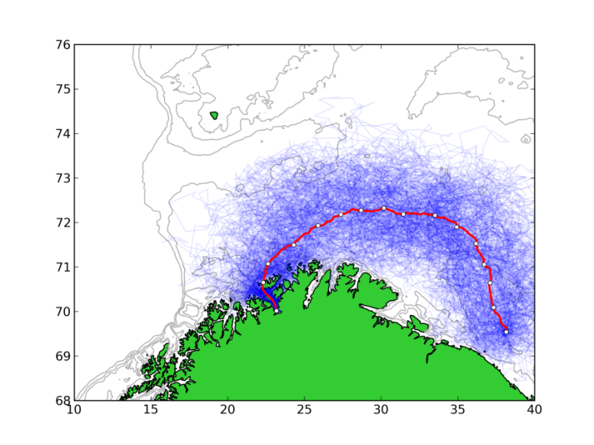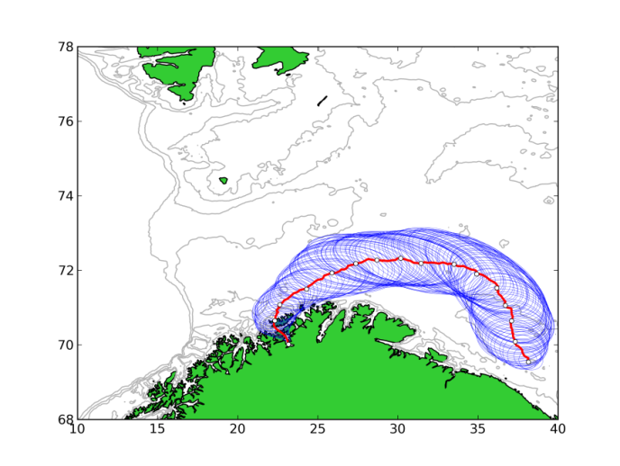

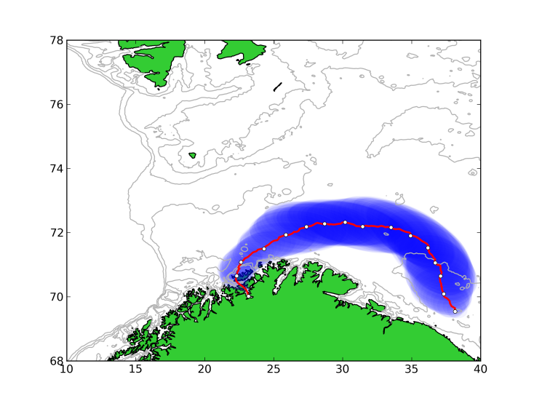Figure 5a

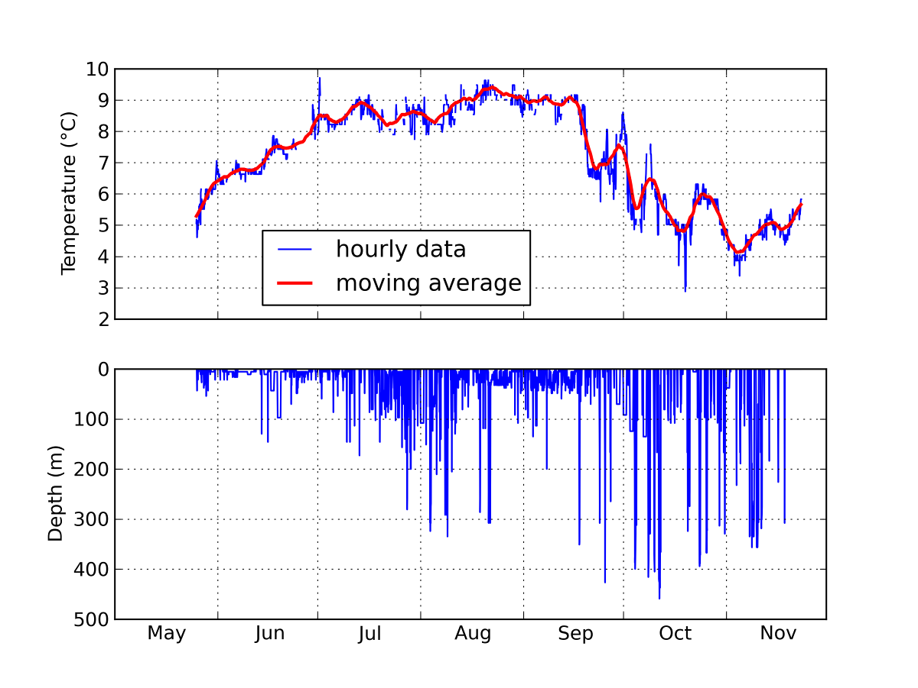

Figure 5b

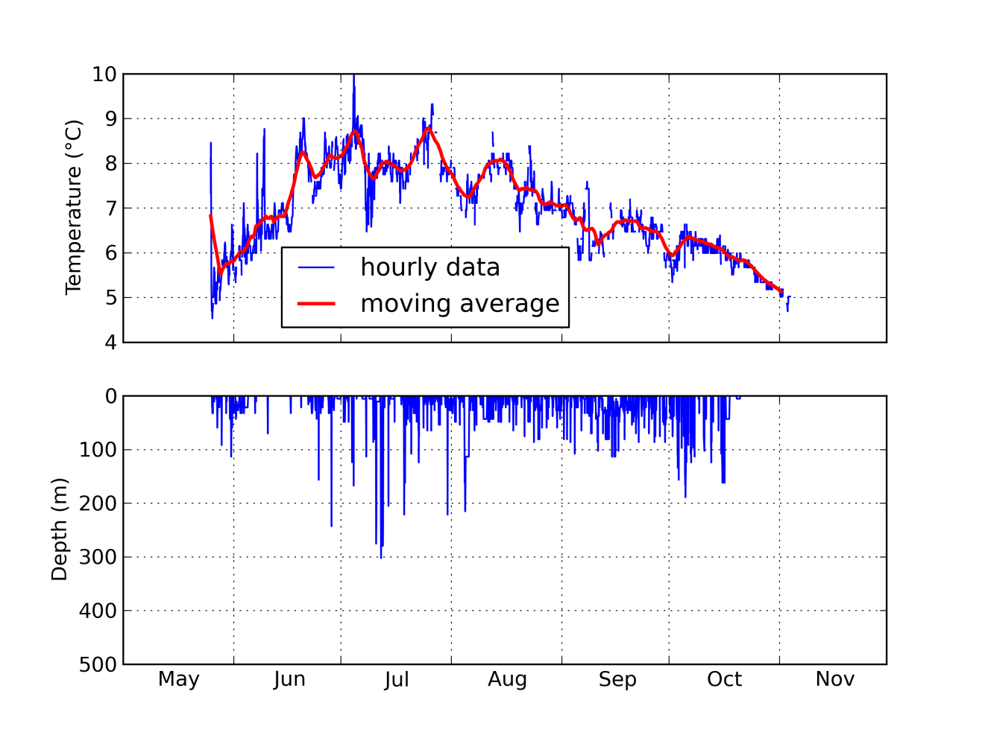Figure 6a

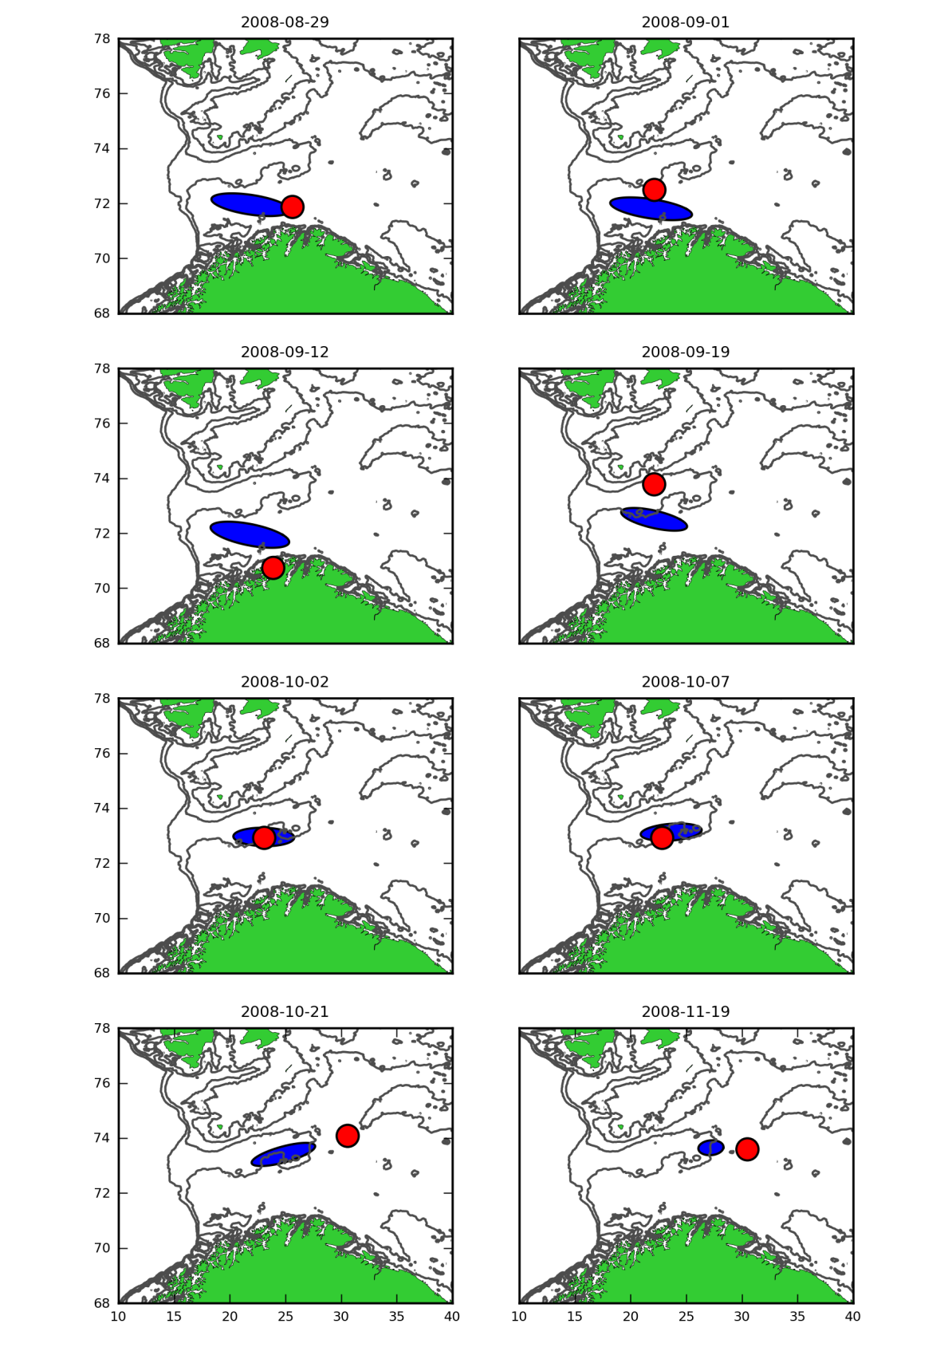

Figure 6b

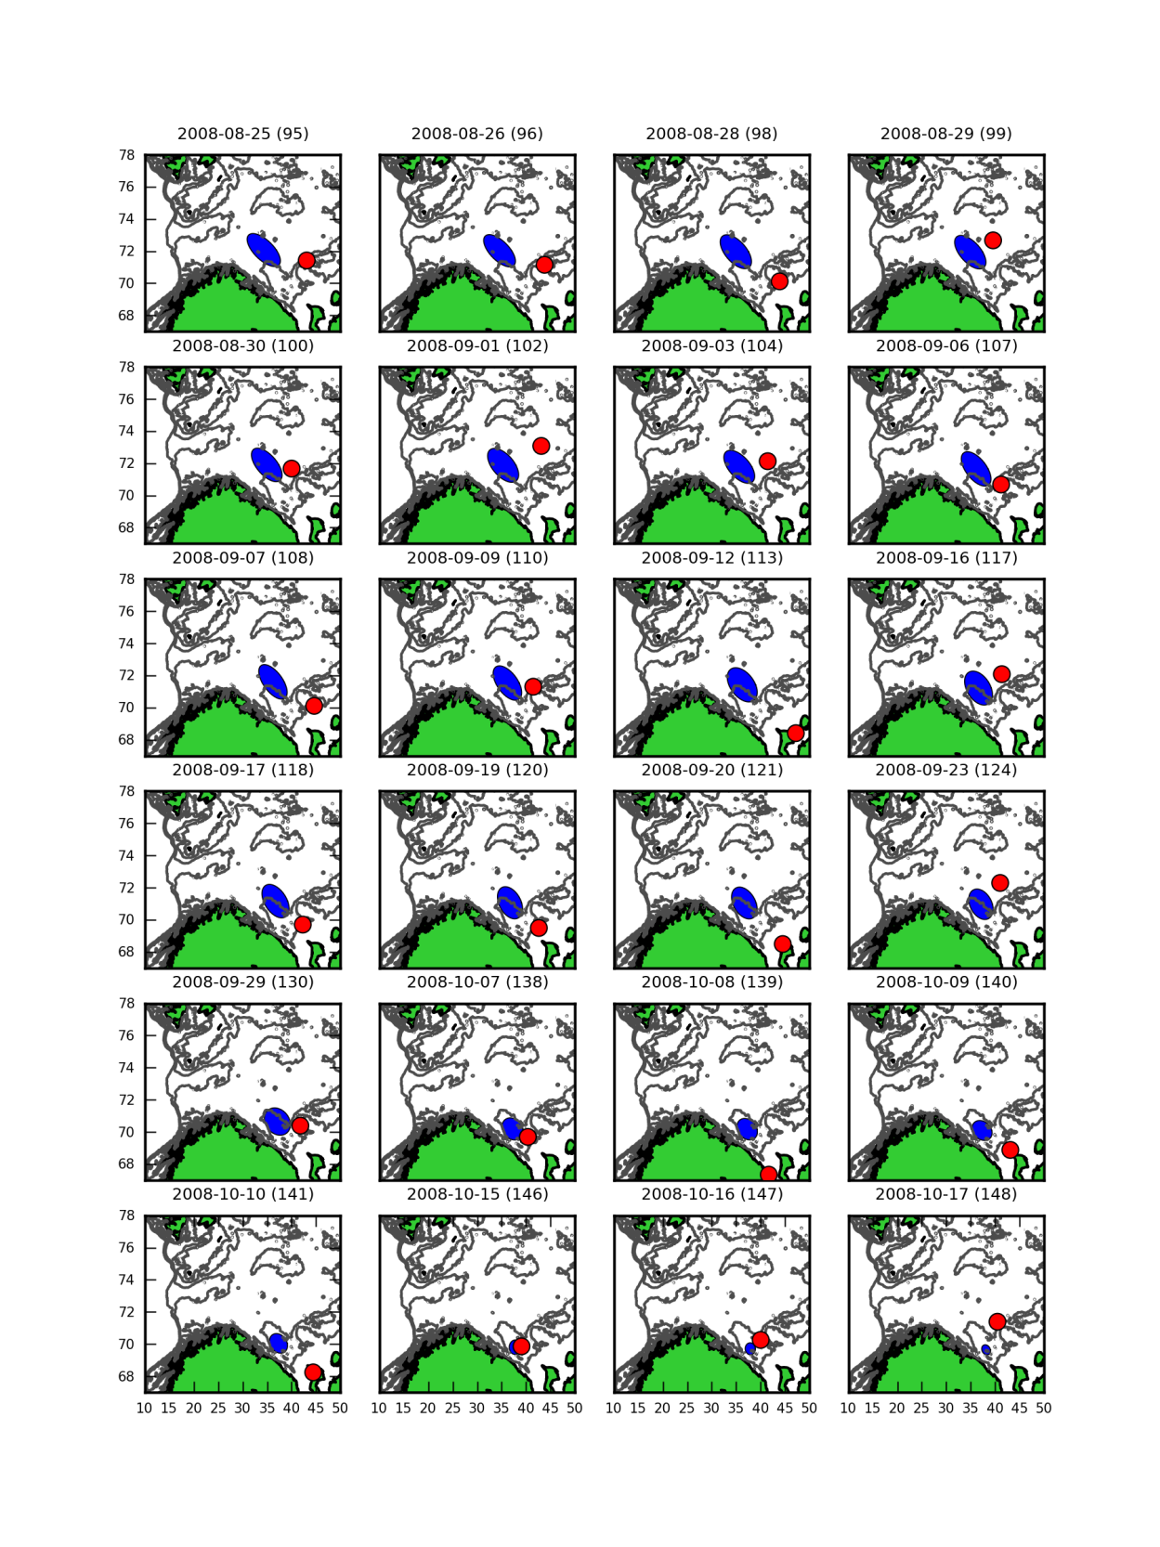Figure 7

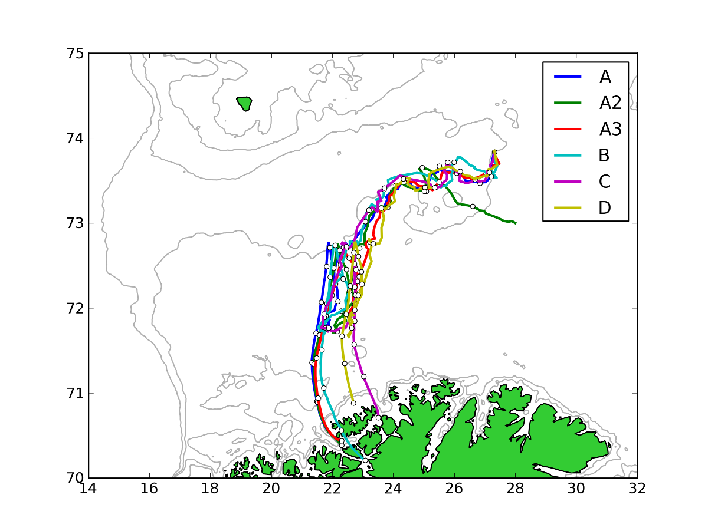

Figure 8

